How to send a DyKnow log report from a student’s computer
YOU MUST BE ON A STUDENT’S COMPUTER TO DO THIS

STEP 1: Click on the folder icon on the task bar
STEP 2: On the left, look for COMPUTER and LOCAL DISK (C:)
(If you can’t see Local Disk (C:) click on Computer for it to appear)
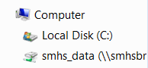
Click on WINDOWS (C:)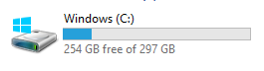
STEP 3: Double click on PROGRAM FILES 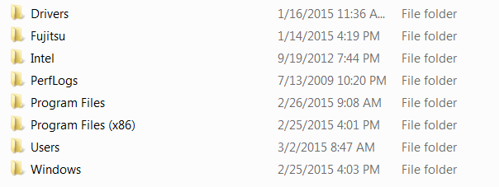
STEP 4: Double click on DYKNOW
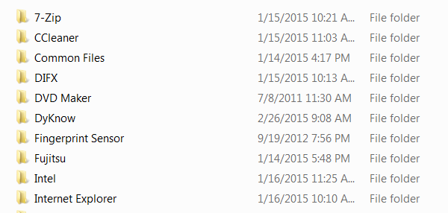
STEP 5: Double click on CLOUD
(OVER)
STEP 6: Double click on DYKNOW LOGSENDER
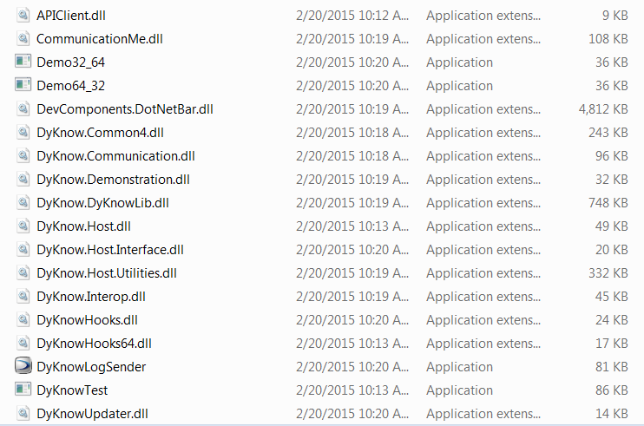
STEP 7: Fill out the necessary information as seen below: student’s name, Drew’s email, school name
BE SURE TO INCLUDE SOME INFORMATION ABOUT THE PROBLEM IN THE NOTES SECTION
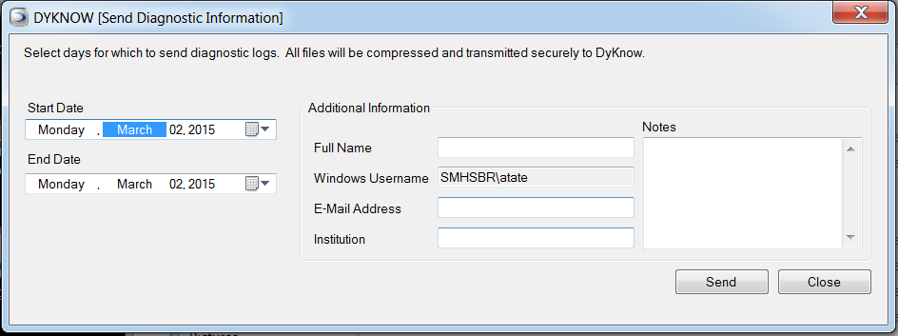
Select range of dates
What’s the problem?
St. Michael High School
dhart@smhsbr.org
Student’s Name

STEP 8: Click the "Send" button and wait for the log files to be transferred to DyKnow. This will send a ticket to DyKnow Support.

